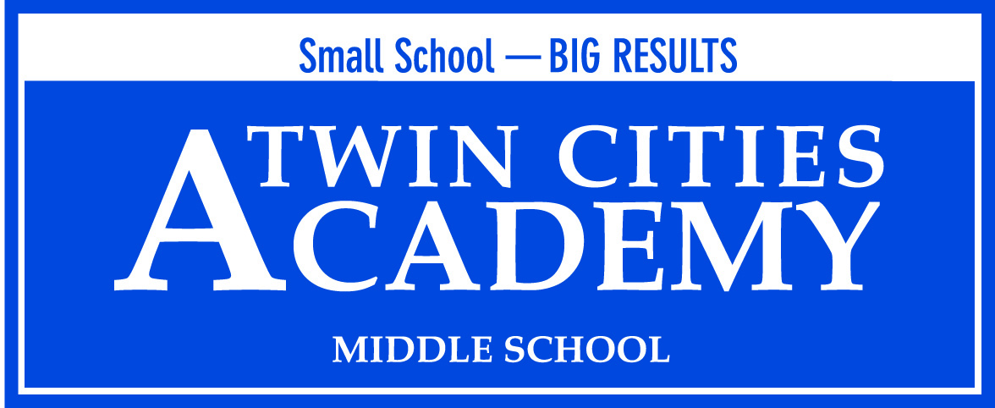

2015-2016

Twin Cities Academy
Annual Charter School Report
(4042-07)

Submitted by Betsy Lueth, Principal

Table of Contents

Academic Elements

Purpose, Vision and Mission

Statutory Statement

Academic Accountability Data

After School Programming

Parent Involvement & Satisfaction Report

Curriculum Report

Schedule Report

Professional Development Report

WBWF Plan

Governance and Operational Elements

Teacher License Verification

Information on Management & Administration

School’s Current Strengths, Challenges & Plans for the Future

School Enrollment

Admissions

Demographic Data

Community Connections & Partnerships

Board Member Orientation & Ongoing Training Plan

Board Member Information

Authorizer Information

Financial Elements

Current Budget

Internal Controls & Board Oversight Procedures

Financial Honors & Audit Information

Purpose

The purpose of this report is to communicate to the constituents of Twin Cities Academy who we are and to monitor and report our annual school data, accomplishments and goals.

Vision

Citizens educated and inspired to make their mark on the world.

Mission

Twin Cites Academy is a St. Paul public school committed to developing productive citizens through academic rigor and building character in partnership with families and the community.

Twin Cities Academy is a public charter middle school located in St. Paul, Minnesota serving grades six, seven and eight. Twin Cities Academy is a college preparatory school committed to academic rigor, active citizenship, and character development. The foundation of our programs supports the student’s ability to be ready for college at the end of their secondary education.

This past year we enrolled 253 students. Although TCA offers a small school environment, our students benefit from a wide variety of courses at the middle school level. All students are able to take a world language, participate in band, and have one quarter of STEM, art, music, literacy, technology and physical education. During after school hours, students are able to participate in sports, science clubs, math clubs or theater along with many other enrichment activities.
Our educational model emphasizes community involvement and relationship building. Families sign a covenant agreeing to share in the partnership of providing support and ensuring success for their children academically, socially, and behaviorally. Our school has a high degree of student and family engagement, reflected in data from 2015-16. Parent/Teacher Conferences held on Saturdays (November, February and April) averaged 93% in attendance

MCA-II, MCA-III and NWEA MAP assessments indicate that we are providing a quality educational experience for our students and they are consistently out-performing many schools in the state including the resident school district, Saint Paul Public Schools. As a public charter school, we offer an academically rigorous educational choice to Minnesota families, and provide our students a high-quality, individualized education.

Twin Cities Academy is focused on the following purposes per Minnesota statute 124D.10: a. improve pupil learning and student achievement; b. measure learning outcomes and create different innovative forms of measuring outcomes; c. create new professional opportunities for teachers, including the opportunity to be responsible for the learning program at the school site.

Academic Program

2015-2016 Academic Accountability Data

Comparison of 2013 to 2014 MCA-II Scores
 | Reading | Math | Science
TCA (FY15) | 65.4% | 51.9% | 59.7%
TCA  (FY16) | 63.6% | 57.0% | 51.2%

Performance to Goal:

- Introduce and implement a Data-Driven Instructional Model, and in so doing, increase overall school proficiency in mathematics by at least 2%, using Spring 2016 MCA-II results. (Assessment Goal)

Performance to Goal Results: The goal was met in Mathematics, but was not met for Reading or Science. Twin Cities Academy does exceed the St. Paul Public Schools in both Mathematics (SPPS: 36.9%) and in Reading (SPPS: 39.0%)

- 75-85% of continuously enrolled eighth graders scored at or above the national average on the ACT-Explore test in mathematics (UST School Specific Goal)

Performance to Goal: 66% of continuously enrolled eighth grade students scored at or above the national average

- Using assessment data, analyze the achievement gap and make curricular/programming changes to address any discrepancies..

Performance to Goal: Twin Cities Academy met this goal and was awarded “Reward” school status by the Minnesota Department of Education

- Identify “at-risk” students in math, reading and writing and implement year-long interventions to be sure they are on track for graduation.

We provided extended classes, courses designed to improve fundamental skills, Reading Extensions and Algebra Extensions, for students who were not performing at grade level. Even though students received additional time and targeted work, we continued to see some students lagging behind their peers. For the 2016-2017 school year, TCAHS has adopted a co-teaching model for all Extensions programming, whereby one content teacher and one Special Education teacher work collaboratively to design and instruct students, with an average class size of 20 or less in each Extensions classroom. Additionally we have redesigned the curriculum and instruction framework for all Extension classes and added a Reading and Math interventionist. All students will also be tested monthly to ensure skills are being mastered using the FAST assessment measure designed by the University of Minnesota.

The current schedule at TCA is well-designed and based on strong practices focused on beating the achievement gap, with double doses of math and reading during the school day.

The full staff is also reviewing student data , two times monthly, based on FAST assessment data, behavioral referrals, and student surveys. During these all staff data meetings, school-wide data and instructional action is determined. Content area departments are also reviewing individual student data monthly focusing on either reading, math, science or behavioral data.

After School Programming

TCA academic day ends at 3:30, at this time all 6th through 8th grade students participate in access (homeroom) groups on Monday, Wednesday and Friday where they receive lessons focused on social emotional health, college-readiness, service-learning, and literacy. On Tuesdays and Thursdays, students participate in enrichment activities including peer tutoring, science clubs, math clubs, theater, sports or art clubs. The TCA buses depart at 4:15.

Parent Involvement and Satisfaction

Under the TCA covenant agreement, which is signed by both parents/guardians and students at the time of enrollment, families are very strongly encouraged to commit to the family-school partnership by attending three conferences per year. The conference attendance rate for the 2015-2016 school year was 97% of all families participating in teacher-family conferences. Additionally all TCA families are strongly encouraged to commit to 20 volunteer hours annually in support of our school-family partnership.

During the third quarter conferences, parents and guardians are also asked to participate in an online satisfaction survey. The quantifiable portion of the family survey for the 2015-2016 school year is provided as an attachment to this report. The questions are scored on a five point Likert Scale, with 1 being strongly disagree and 5 being strongly agree.

Curriculum Report

Twin Cities Academy is committed to providing a college preparatory program. Courses at TCA prepare students for advanced courses in high school which will lead them to college. To support the rigorous requirements for advanced classes in high school, world languages begin in the sixth grade for most students. For students who are not at grade level in math or English, additional support classes in one or both of these core courses are offered. Students in the sixth grade also receive an additional semester of physical education along with a rotating physical education class all year long. Seventh graders receive an additional semester of music and eighth graders receive an additional semester in art. All students receive a semester of STEM and a trimester of literacy, along with year-long courses in math, English, science, social studies and world languages. The goal of the TCA curriculum is to offer a liberal arts focus with rigor infused in all coursework. All courses are aligned to Minnesota state standards.

Schedule Report

The Twin Cities Academy daily schedule consists of seven class periods at approximately 50 minutes each. Each course meets daily for a total student contact calendar of 177 days. Teachers work 194 days, with seven days of workshops prior to students returning each school year and an additional six days of professional development spread out throughout the school year. Every Wednesday courses are shortened by approximately five minutes to allow for a sixty-minute forum period. During every other forum students who are falling behind in their homework are required to attend a tutorial session to catch up, while other students participate in “fun rooms.” During the other weeks, forums are all school and include social emotional presentations such as by Climb Theater on bully prevention, for example.

Professional Development Report

Twin Cities Academy provides high quality instruction through its fully implemented data driven instruction focus. Course planners tie all curriculum used in the classroom to standards, formative assessments are designed to test student proficiency on the standards at a minimum monthly, data is reviewed by administration and in collaboration with content level teams.

All teachers participate in weekly professional learning teams designed to promote collaboration. Two times in the month teachers are collaborating in content specific teams, one time a month content area teams are paired for collaborating (math with science or English with social studies, for example), and one time a month teachers meet in grade level collaborative teams. By planning for flexible teaming, collaboration throughout the building is both broad and comprehensive to meet a variety of instructional needs.

All professional development for the 2016-2017 school year is designed to offer training and support in the Instructional Discipline and Culturally Sensitive Curriculum approaches. Based on the continuing racial conflict in our minitorized communities, and the need to develop a more equitable and relationship-based school climate and culture, the administration and faculty are actively pursing these two initiatives in tandem to meet the changing needs of our students.

Governance and Management

Teacher Licensure Verification – See Attachment

Information on Management and Administration

For the 2015--2016 school year, Betsy Lueth, principal, functioned as the single leader of the school, and be the only direct report to the school board. Ms. Lueth is a MN licensed K-12 principal with eight years of administrative experience in charter schools. The 2016-2017 school year will be her fifth year at Twin Cities Academy.

Administration Staff:

Name | File Number | Assignment | Yrs. w/ School | Status
Lueth, Betsy | 397306 | Principal | 4 | Returning Fall 2016
Ausen, Terri |  | Office Manager | 7 | Returning Fall 2016
Delesha, Lynn |  | Library Aide | 1 | Returning Fall 2016
Bowler, Michele |  | Office Assistant | 1 | Not Returning Fall 2016
Fleischhacker, Laverne |  | Cafeteria | 17 | Returning Fall 2016
Allen, Branch |  | Cafeteria/Custodian | 1 | Returning Fall 2016
Zakrzewski, JoAnn |  | Cateteria | 4 | Returning Fall 2016
Tofte, Terry |  | Operations Manager | 3 | Returning Fall 2016

Current Strengths, Challenges and Plans for the Future

Twin Cities Academy has much to celebrate from the 2015-2016 school year. TCA was named as a “Reward” school. This is a higher designation than last year, when TCA was named a “Celebration Eligible” school.

Twin Cities Academy is equally excited that it has moved into its newly built facility as of July 1, 2016. This 63,000 square foot facility allows for more supported secondary programming, with a full size gymnasium, ball fields, stage, and science labs. Additionally Twin Cities Academy High School has officially merged with its sister-school Twin Cities Academy High School, and has been renamed Twin Cities Academy serving students in a continuously articulated 6-12 grade program.

School Enrollment

For several years, enrollment at Twin Cities Academy has been sustained right below 200.

Year | Grade 6 | Grade 7 | Grade 8 | Total School Population
2009-2010 | 53 | 68 | 78 | 199
2010-2011 | 56 | 64 | 70 | 190
2011-2012 | 52 | 72 | 69 | 193
2012-2013 | 50 | 72 | 75 | 197
2013-2014 | 58 | 73 | 71 | 202
2014-2015 | 77 | 75 | 63 | 215
2015-2016 | 84 | 86 | 83 | 253
Estimated 2016-2017 | 107 | 104 | 101 | 312

Admissions

Twin Cities Academy is dedicated to a free-access quality education, without discrimination, and follows all Minnesota statutes as they relate to application and admission procedures for charter schools. Enrollment is open to all middle school students residing in any school district in Minnesota.
TCA holds open houses and accepts applications throughout the year. Per the school board adopted enrollment policy, the school board establishes the open enrollment period applicable to the following school’s year admission by October 1st or the current year. Available enrollment seats by grade is published by February 1st of the current year for the following year, which will always be prior the last day of the open enrollment period, and the lottery, if a lottery is required. Lottery numbers are generated electronically and drawn randomly through a computer program. Lottery results are mailed to families.
Students submitting applications after the last day of the open enrollment period, are placed on our waiting list and acceptance is based on space availability.
Once students are accepted, they are then asked to complete a registration packet, attend a covenant meeting, and participate in new student orientation. Please refer to the TCA enrollment application on the next page of this document.

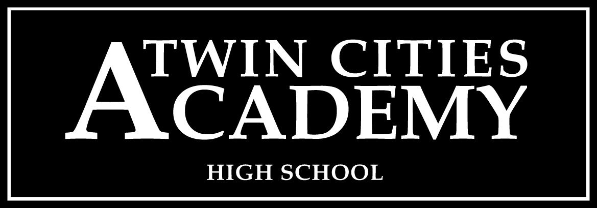
A St. Paul Charter School for Grades 6 thru 12

STUDENT INFORMATION

Last Name ____________________________________ First Name __________________________________

Current Grade ______ Grade Next Fall ______ School Year Applying For: 20____ - 20_____

Home Address ____________________________________________________ Apartment ________________

City & State_____________________ Zip Code _____________ Home Phone __________________________

Sibling Enrolled at TCA* _____ Yes _____ No Sibling Enrolled at TCAHS* _____ Yes _____ No

PARENT / GUARDIAN INFORMATION

Parent / Guardian __________________________________ Work Phone _____________________________

Cell Phone _______________________________________ Email ___________________________________

Parent / Guardian __________________________________ Work Phone _____________________________

Cell Phone _______________________________________ Email ___________________________________

*Twin Cities Academy’s enrollment is independent of Twin Cities Academy High School. Alumni and sibling preference does not transfer between TCA and TCAHS.

_____________________________________________________________ ________________________
Signature of Parent / Guardian Date
"A charter school shall enroll an eligible pupil who submits a timely application, unless the number of applications exceeds the capacity of a program, class, grade level, or building. In this case, pupils must be accepted by lot. A charter school shall give preference for enrollment to a sibling of an enrolled pupil and to a foster child of that pupil's parents before accepting other pupils by lot. If a charter school is the only school located in a town serving pupils within a particular grade level, then pupils that are residents of the town must be given preference for enrollment before accepting pupils by lot. A charter school may not limit admission to pupils on the basis of intellectual ability, measures of achievement or aptitude, or athletic ability."MS124d.10 Subd.9.

If applying for enrollment during the current school year, please contact the school office.

OFFICE USE ONLY: Date Received _________________________ Lottery Number ________________
Lottery Drawing Held February 28th

835 5th Street East St. Paul, MN 55106 (651) 205-4797 Fax (651) 205-4799 09/11

Student Demographic Data for 2015-16

Gender

 | Male | Female | Total | Male/Female Ratio
2015-16 | 126 | 127 | 253 | 50%/50%

Proportion of Males and Females, 2015-16

Race/Ethnicity

In 2012-13, approximately 45% of the students were of color.

 | Asian  American | Black American | Hispanic | White | Two or more races | American Indian | Total
No. of Students | 28 | 48 | 31 | 122 | 23 | 1 | 253
% | 11.0% | 19.0% | 12.3% | 48.2% | 9.0% | 0.5% | 100%

Free & Reduced Lunch

 | No. of Students | % to Total School Enrollment
Free Lunch | 67 | 26.5%
Reduced Lunch | 32 | 12.7%
Combined Free & Reduced | 99 | 39.2%
No Lunch Assistance | 154 | 60.8%

Special Education

No. of Students | % to Total  School Total | Primary Disability | Students Per Category
21 | 8.3% | - Speech & Language  - SLD  - OHD  - Autism  - Vision  - EBD  - DCD | 4  5  5  4  1  1  1

Limited English Proficiency

No. of Students | % to Total School Enrollment
0.7% | 1.6%

Community Connections and Partnerships

TCA students benefit from college tutors from the University of St. Thomas, and a new program is being designed to bring in local retired college professors to help students with college applications. Additionally TCA has partnerships with Dodge Nature Center and Park Square Theater to offer enrichment opportunities to our students.

TCA is also a member of the Eastside Area Business Association, and principal Betsy Lueth regularly attends monthly luncheon events to promote the school and participate in the Eastside business initiatives. As a part of the Eastside, TCAHS also participates in local festivals and marches in local parades such as the Rice Street Parade.

Board of Directors

TCA’s governing board includes teachers, parents, and community members. The following chart shows membership for 2015-16.

Board Membership – See attached.

Professional development is scheduled for the governing board, both as a group (total board trainings) and individually. Minnesota Charter Law mandates ongoing education for the governing board, in which TCAHS is compliant. From July 2015 to June 2016, Board Members attended the following training sessions:
- BKDA Training on how to manage Municipal Bond Covenants: Jenny Abbs, BKDA June 2016. (Full Board)

All board members satisfied the state required board training in board governance, personnel/employment and finances. Services were provided by the MN School Board Association, Non-Profit Assistance Fund or the University of St. Thomas.

Authorizer Information

Authorizer | Contact Information | Liaison | Contract Expiration
University of St. Thomas | University of St. Thomas  1000 LaSalle Street  Minneapolis, MN  651-962-4844 | Molly McGraw-Healy  mccgraw@stthomas.edu | June 30, 2018

Because charter schools are not part of traditional community school districts, they are accountable to the State of Minnesota for student learning and financial performance through a state-approved charter school overseer, or authorizer. Our authorizer is The University of St. Thomas, in St. Paul, Minnesota. Their role is to ensure that we are true to our school’s mission; provide continued quality of our academic programs as demonstrated by quantifiable student learning; that we meet parents’ expectations and satisfaction; and that we comply with state and federal mandates. We submit our School Board minutes and financial statements monthly to the University of St Thomas. They have agreed to be our authorizer for two years.

Finances

Twin Cities Academy is on solid financial footing. The school entered the 2016-17 school year with a positive fund balance of $718,389.

The Board, primarily through the Finance Committee, actively partners with the principal/ to oversee financial matters. BKDA Accounting firm in collaboration with the principal compiles and presents a financial report to the Board monthly. This report is a review of checking and savings account balances, fund balance, and income and expenses statements. These financial statements are provided to the treasurer and finance committee members a week before the board meeting. The Board reviews and analyzes all budgets, expenditures, and bank statements, and provides monthly/quarterly financial statements to the authorizer.

Following is a summary of TCA’s budget and actual (unaudited) financial results for Fiscal Year 2014 as well as our financial position at June 30, 2014. TCA is expected to utilize $393,469 from the fund balance based on the unaudited financials at the end of June 30, 2016. This represents a 18.9% fund balance with an expected total amount in the fund balance of $718,389 (unaudited). The final audited financials will be available in December 2014.

The audit for the fiscal year 2015 contained no material weaknesses or significant deficiencies as prepared by MMKR audit firm and presented to the school board during the spring of 2016.

The school board and administration chose to pursue working with Belz, Kes, Darling and Associates and have also employed an internal business manager Dr. Terry Tofte to prepare and review the financials in collaboration with the principal. The board and the principal will continue to oversee the overall financial health of the school, on a monthly basis through review of detailed finances in the board finance sub-committee, and by presenting the financials monthly to the full school board during the regular school board meeting.. By using an outside firm such as BKDA, Twin Cities Academy is assured to have strong internal controls and procedures in place to continue financial health and clean audits.

The Twin Cities Academy School Board deliberately adopted a deficit budget for FY16 to utilize fund balance to contribute to equipment and furniture for the new school building.

Fund Balance:
Un-audited fund balance as of June 30, 2015 - $718,389

2015-2016 Annual Audit Report –
MMKR Certified Public Accountants & Co.
55353 Wayzata Blvd. Suite 410
Minneapolis, MN 55416

