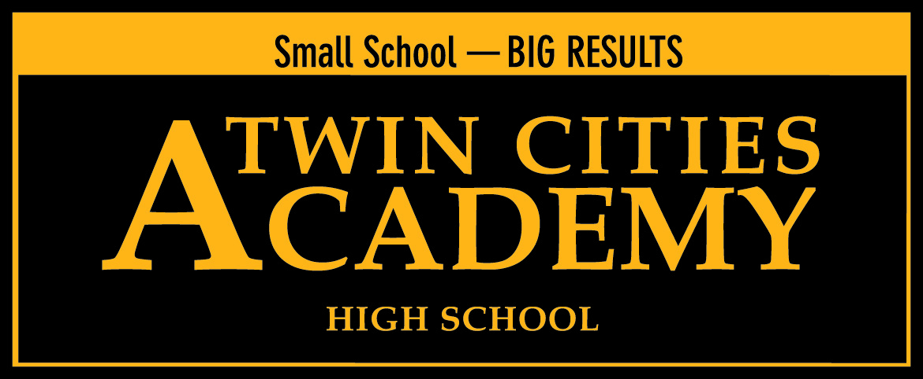

2015-2016

Twin Cities Academy High School
Annual Charter School Report
(4132-07)

Submitted by Betsy Lueth, Principal

Table of Contents

Academic Elements

Purpose, Vision and Mission

Statutory Statement

Academic Accountability Data

After School Programming

Parent Involvement & Satisfaction Report

Curriculum Report

Schedule Report

Professional Development Report

WBWF Plan

Governance and Operational Elements

Teacher License Verification

Information on Management & Administration

School’s Current Strengths, Challenges & Plans for the Future

School Enrollment

Admissions

Demographic Data

Community Connections & Partnerships

Board Member Orientation & Ongoing Training Plan

Board Member Information

Authorizer Information

Financial Elements

Current Budget

Internal Controls & Board Oversight Procedures

Financial Honors & Audit Information

Purpose
The purpose of this report is to communicate to the constituents of Twin Cities Academy High School who we are and to monitor and report our annual school data, accomplishments and goals.

Mission

Twin Cites Academy High School is committed to enhancing the capacity of young adults in developing one’s ability to lead in an ever-changing world through academic rigor, leadership development, and character building.

Twin Cities Academy High School (TCAHS) is a college preparatory public charter high school authorized by the University of St. Thomas. TCAHS is located near downtown St. Paul, Minnesota and serves grades 9-12.

TCAHS opened in the fall of 2006 with grades 9 and 10. The school expanded a grade each of the two subsequent years, and by the 2008-09 school year was fully articulated with 9-12th grades. TCAHS has a current enrollment near 300 students, and a capacity to serve up to 350 students.

Twin Cities Academy High School is committed to preparing our students for postsecondary education. Our college preparatory program and instruction for 9th-12th grade youth concentrates on mastery of grade level skills in accordance with state and federal educational mandates, college readiness, service-learning and development of higher-order critical thinking and life skills. High academic and behavioral expectations are infused in the program along with character and leadership development. All-school volunteerism is a key component of the program with both group and individual community service expectations. The foundation of our program supports the student’s ability to be ready for college at the end of their secondary education. Last year % of our graduates continued their education beyond high school.
There are many reasons families and students choose us, including our reputation, our educational model, and our outstanding results. As a public charter school, we are different from traditional public schools. We have the freedom to commit ourselves to a specific education model that we believe makes our students successful. Families who entrust their children to us also commit to this model. We maintain high expectations of our students, and hold accountability as one of our core values. We provide a robust and disciplined environment: we meet students where they are in their development and encourage them to build self-confidence through hard work and well-earned success. We are committed to providing opportunities and experiences that allow our students to be and do their very best, assisting all our students to meet educational goals and begin developing important and lifelong skills. Because of our small school environment, we are able to focus on each individual while also building community. Our educational model emphasizes community involvement and relationship building. Connections between our middle and high school students help develop a whole community of learners. This is the educational choice we offer to Minnesota families: a high-quality, individualized educational experience.
Twin Cities Academy High School is focused on the following purposes per Minnesota statute 124D.10: a. improve pupil learning and student achievement; b. measure learning outcomes and create different innovative forms of measuring outcomes; c. create new professional opportunities for teachers, including the opportunity to be responsible for the learning program at the school site.

Academic Program

2015-2016 Academic Accountability Data

Comparison of 2013 to 2014 MCA-II Scores
 | Reading | Math | Science
TCAHS (FY15) | 66.1% | 60.8% | 62.2%
TCAHS  (FY14) | 59.7% | 40.0% | 40.6%

Performance to Goal:

- Maintain Proficiency in Math, Science and Reading above the State Proficiency level. (Assessment Goal)

Performance to Goal Results: TCAHS students scored on par in Reading with the State Proficiency level (State: 59.7%) and lagged in Math (State: 59.4%) and in Science (State: 54.7%). TCAHS did score consistently higher that St. Paul Public Schools in Reading (SPPS: 38.7%) and Math (SPPS: 30.2%).

- Maintain a high school graduation rate of 100% (UST School Specific Goal)

Performance to Goal: Every student enrolled in 12th grade during the 2015-16 school year, met our graduation requirements, one completed requirements during the summer of 2016. Additionally, 90% of our graduates had plans to continue their higher education, and were accepted at a postsecondary institution at the time of their graduation.

- Using assessment data, analyze the achievement gap and make curricular/programming changes to address any discrepancies.

Performance to Goal: TCAHS administration and teachers have analyzed assessment data in depth to properly support students who are demographically identified as students constituting the achievement gap as defined by the MMR. TCAHS was identified by the MDE for the sixth year in a row as a “Reward” school, based on the 2015-2016 MCA results.

- Identify “at-risk” students in math, reading and writing and implement year-long interventions to be sure they are on track for graduation.

We provided extended classes, courses designed to improve fundamental skills, Reading Extensions and Algebra Extensions, for students who were not performing at grade level. Even though students received additional time and targeted work, we continued to see some students lagging behind their peers. For the 2016-2017 school year, TCAHS has adopted a co-teaching model for all Extensions programming, whereby one content teacher and one Special Education teacher work collaboratively to design and instruct students, with an average class size of 20 or less in each Extensions classroom. Additionally we have redesigned the curriculum and instruction framework for all Extension classes and added a Reading and Math interventionist. All students will also be tested monthly to ensure skills are being mastered using the FAST assessment measure designed by the University of Minnesota.

The current schedule at TCAHS is well-designed and based on strong practices focused on beating the achievement gap, with double doses of math and reading during the school day

The full staff is also reviewing student data ,two times monthly, based on FAST assessment data, behavioral referrals, and student surveys. During these all staff data meetings, school-wide data and instructional action is determined. Content area departments are also reviewing individual student data monthly focusing on either reading, math, science or behavioral data.

After School Programming

TCAHS academic day ends at 3:30, at this time all 9th through 12th grade students are encouraged to participate in office hours, clubs, or other social activities. The TCAHS buses depart at 4:15. Office hours are designed to provide time directly after school for students to receive individualized attention from teachers on their homework or to re-take tests. During this time students may also participate in a club. All clubs are proposed and run by students with a faculty supervisor. Clubs currently include Socrates Café, Latin, Yoga, Anime, and Technology. Students may also be required to attend office hours through our mandatory office hour policy. Any student with two or more F’s in any class after grade checks (done every 2 ½ weeks) are assigned to teachers’ office hours for four days of the week until grades improve.

Parent Involvement and Satisfaction

Under the TCAHS covenant agreement, which is signed by both parents/guardians and students at the time of enrollment, families are very strongly encouraged to commit to the family-school partnership by attending three conferences per year. The conference attendance rate for the 2015-2016 school year was 86% of all families participating in teacher-family conferences.

During the third quarter conferences, parents and guardians are also asked to participate in an online satisfaction survey. The quantifiable portion of the family survey for the 2015-2016 school year is provided as an attachment to this report. The questions are scored on a five point Likert Scale, with 1 being strongly disagree and 5 being strongly agree.

Curriculum Report

Twin Cities Academy High School is committed to providing a college preparatory program. Courses at TCAHS prepare students for matriculation into college. Courses are either one semester or one year, and .5 credit is granted at the end of each semester. Students must earn 24 credits to graduate from TCAHS. Our students take mathematics and science in all 4 years of high school. Students have options for accelerated coursework, including Advanced Placement courses, College in the Schools, or Post Secondary Enrollment Options (PSEO) college courses. Our academic program responds to the needs of the students. We provide struggling learners with additional support, in the form of supportive and extended classes, remediation, tutoring, modifying instruction and curriculum, and child study meetings, so they can experience academic success.

College professors communicate that the areas of most concern for incoming collegiate freshmen are mathematics, writing, and study habits. TCAHS offers courses focused on building these essential skills to ensure college readiness. TCAHS curriculum is focused on the Minnesota state standards. All teachers are required to develop a course planner, which identifies the standards students must master, and the instructional activities and essential questions for each unit. To ensure students are prepared for college-level course work, many classes are aligned to ACT and College-Board AP standards and benchmarks.

In order to develop the college and career ready habits of mind, along with the academic skills, a team of teachers and administrators, have designed a fully articulated 9th through 12th grade college-readiness curriculum. This curriculum was prepared to help students identify strengths and weaknesses in their own study habits, and survey them for interest areas to pursue in post-secondary education. Logistical skills are also taught such as how to design a resume, college application and fill out FAFSA forms.

In the 2016-2017 school year all 9th graders will now have one semester of Study Skills, and all 12th graders will have one semester of Senior Seminar. Both courses are designed to help students prepare for the next step in their academic career.

The academic program also includes components such as internships, teaching assistantships, and community service. These real-life challenges and opportunities provide students with chances to learn about and pursue career options. TCAHS believes that in order for students to become leaders, they must have an understanding of the needs that exist in the community and the world. The school strongly supports service learning. In addition, all TCAHS students are required to independently contribute 20 hours of volunteer service at an organization of their choice. The service-learning curriculum was designed and implement for the first time during the 2013-2014 school year. Each advisory group selected a local non-profit to work with and support throughout the school year. This resulted in students working monthly for or at the local non-profit for a minimum of two hours. Students then prepared a paper or presentation to share with the whole school at the end of the school year during the service learning consortium event.

Schedule Report

The Twin Cities Academy High School daily schedule consists of seven class periods at approximately 50 minutes each. Each course meets daily for a total student contact calendar of 177 days. Teachers work 194 days, with five days of workshops prior to students returning each school year and an additional eight days of professional development spread out throughout the school year, and five days after the last instructional day. Every Wednesday courses are shortened by approximately five minutes to allow for a sixty-minute advisory period. During advisory, grade level groups consisting of 20 students per group work on either service-learning or college-readiness curriculum.

Professional Development and Teacher Evaluation

Twin Cities Academy High School provides high quality instruction through its fully implemented data driven instruction focus. Course planners tie all curriculum used in the classroom to standards, formative assessments are designed to test student proficiency on the standards at a minimum monthly, data is reviewed by administration and in collaboration with content level teams.

All teachers participate in weekly professional learning teams designed to promote collaboration. Two times in the month teachers are collaborating in content specific teams, one time a month content area teams are paired for collaborating (math with science or English with social studies, for example), and one time a month teachers meet in grade level collaborative teams. By planning for flexible teaming, collaboration throughout the building is both broad and comprehensive to meet a variety of instructional needs.

All professional development for the 2016-2017 school year is designed to offer training and support in the Instructional Discipline and Culturally Sensitive Curriculum approaches. Based on the continuing racial conflict in our minitorized communities, and the need to develop a more equitable and relationship-based school climate and culture, the administration and faculty are actively pursing these two initiatives in tandem to meet the changing needs of our students.

The teacher evaluation system at Twin Cities Academy High School during 2015-2016 consisted of multiple measures, and Q Comp performance pay was aligned with the measures proportionately. Teachers are evaluated based on student performance on standardized tests (MCA III and NWEA), school-wide goals. Administrative Evaluation (one formal per year for veteran staff, three per year for new staff), Peer Evaluations (two per year for all veteran staff), Student Engagement Survey, review of Data-Driven Instruction portfolio, and support of outside activities including chaperoning events, participating in supporting students outside of the academic day. For the 2015-2016 the Administration at TCAHS has added informal walk-through observations, two times monthly, for all teachers as well to the evaluation process.

Governance and Management

Teacher Licensure Verification – See Attachment

Information on Management and Administration

For the 2015-2016 school year, Betsy Lueth, principal/executive director, functioned as the single leader of the school, and was the only direct report to the school board. Ms. Lueth is a MN licensed K-12 principal with ten years of administrative experience in charter schools. The 2016-2017 school year will be her fifth year at Twin Cities Academy.

Administration Staff:

Name | File Number | Assignment | Yrs. w/ School | Status
Lueth, Betsy | 397306 | Principal | 4 | Returning Fall 2016
Ausen, Terri |  | Office Manager | 7 | Returning Fall 2016
Delesha, Lynn |  | Library Aide | 1 | Returning Fall 2016
Bowler, Michele |  | Office Assistant | 1 | Not Returning Fall 2016
Fleischhacker, Laverne |  | Cafeteria | 17 | Returning Fall 2016
Allen, Branch |  | Cafeteria/Custodian | 1 | Returning Fall 2016
Zakrzewski, JoAnn |  | Cateteria | 4 | Returning Fall 2016
Tofte, Terry |  | Operations Manager | 3 | Returning Fall 2016

Current Strengths, Challenges and Plans for the Future

Twin Cities Academy High School has much to celebrate from the 2015-2016 school year. TCAHS was named as a “Reward” school for the sixth year in a row by the Minnesota Department of Education.

Twin Cities Academy High School is equally excited that it has moved into its newly built facility as of July 1, 2016. This 63,000 square foot facility allows for more supported secondary programming, with a full size gymnasium, ball fields, stage, and science labs. Additionally Twin Cities Academy High School has officially merged with its sister-school Twin Cities Academy, and has been renamed Twin Cities Academy serving students in a continuously articulated 6-12 grade program.

School Enrollment

For several years, enrollment at Twin Cities Academy has been sustained right below 200.

Year | Grade 9 | Grade 10 | Grade 11 | Grade 12 | Total School Population
2009-2010 | 36 | 38 | 18 | 28 | 120
2010-2011 | 46 | 39 | 28 | 16 | 129
2011-2012 | 60 | 54 | 28 | 23 | 165
2012-2013 | 60 | 54 | 45 | 25 | 184
2013-2014 | 66 | 60 | 48 | 37 | 211
2014-2015 | 72 | 62 | 49 | 43 | 226
2015-2016 | 81 | 69 | 55 | 44 | 249
2016-2017  Projected | 107 | 85 | 64 | 53 | 309

Admissions

Twin Cities Academy High School is dedicated to a free-access quality education, without discrimination, and follows all Minnesota statutes as they relate to application and admission procedures for charter schools. Enrollment is open to all high school students residing in any school district in Minnesota.
TCAHS holds open houses and school tours, and accepts applications throughout the year. Enrollment Applications received prior to the school deadline of February 28th each year are eligible for the enrollment lottery. If we have received more applications for admission than we have vacancies in classes, TCAHS holds a lottery drawing on February 28th of each year (as needed) to determine admission and class enrollment for new students. Lottery numbers are generated electronically and drawn randomly through a computer program. Lottery results are mailed to families.
Students submitting applications after February 28th are placed on our waiting list and acceptance is based on space availability. Once students are accepted, they are then asked to complete a registration packet, attend a covenant meeting, and participate in new student orientation.

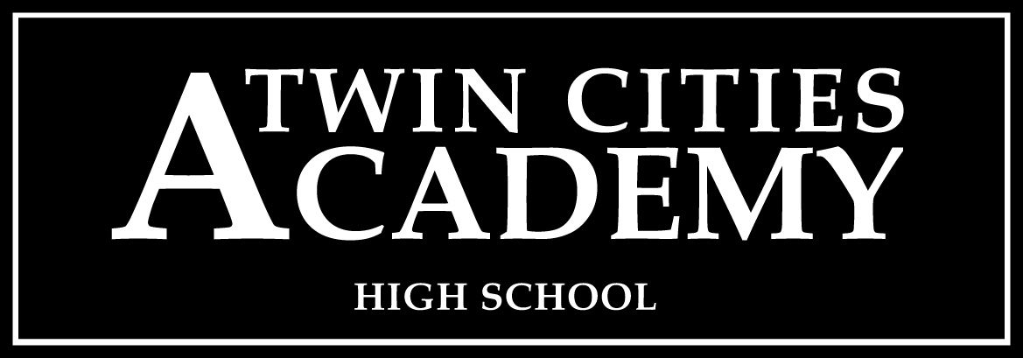
A St. Paul Charter School for Grades 6 thru 12
STUDENT INFORMATION
Last Name ____________________________________ First Name __________________________________

Current Grade ______ Grade Next Fall ______ School Year Applying For: 20____ - 20_____

Home Address ____________________________________________________ Apartment ________________

City & State_____________________ Zip Code _____________ Home Phone __________________________

Sibling Enrolled at TCA* _____ Yes _____ No Sibling Enrolled at TCAHS* _____ Yes _____ No

PARENT / GUARDIAN INFORMATION

Parent / Guardian __________________________________ Work Phone _____________________________

Cell Phone _______________________________________ Email ___________________________________

Parent / Guardian __________________________________ Work Phone _____________________________

Cell Phone _______________________________________ Email ___________________________________

*Twin Cities Academy’s enrollment is independent of Twin Cities Academy High School. Alumni and sibling preference does not transfer between TCA and TCAHS.
_____________________________________________________________ ________________________
Signature of Parent / Guardian Date
"A charter school shall enroll an eligible pupil who submits a timely application, unless the number of applications exceeds the capacity of a program, class, grade level, or building. In this case, pupils must be accepted by lot. A charter school shall give preference for enrollment to a sibling of an enrolled pupil and to a foster child of that pupil's parents before accepting other pupils by lot. If a charter school is the only school located in a town serving pupils within a particular grade level, then pupils that are residents of the town must be given preference for enrollment before accepting pupils by lot. A charter school may not limit admission to pupils on the basis of intellectual ability, measures of achievement or aptitude, or athletic ability."MS124d.10 Subd.9.

If applying for enrollment during the current school year, please contact the school office.

OFFICE USE ONLY: Date Received _________________________ Lottery Number ________________
Lottery Drawing Held February 28th

835 5th Street East St. Paul, MN 55106 (651) 205-4797 Fax (651) 205-4799 09/11

Student Demographic Data for 2015-16

Gender

 | Male | Female | Total | Male/Female Ratio
2015-16 | 101 | 148 | 249 | 40.5%/59.5%

Proportion of Males and Females, 2012-13

Race/Ethnicity

In 2015-16, 45.6% of the students were of color.

 | Asian  American | Black American | Hispanic | White | American Indian | Two or More Races | Total
No. of Students | 15 | 63 | 62 | 97 | 1 | 11 | 249
% | 6.0% | 25.3% | 24.9% | 38.9% | 0.4% | 4.5% | 100%

Free & Reduced Lunch

 | No. of Students | % to Total School Enrollment
Free Lunch | 107 | 43%
Reduced Lunch | 29 | 12%
Combined Free & Reduced | 136 | 55%
No Lunch Assistance | 113 | 45%

Special Education

No. of Students | % to Total  School Total | Primary Disability | Students Per Category
24 | 9.6% | - Speech & Language  - SLD  - OHD  - Autism  - Vision  - EBD  - DHH | 0  14  8  1  0  1  1

Limited English Proficiency

No. of Students | % to Total School Enrollment
4 | 1.6%

Community Connections and Partnerships

Twin Cities Academy High School has partnerships with several local non-profits through its student service-learning programming. Some of these non-profits include Books for Africa, Urban Roots, Friends of Swede Hollow, Second Harvest Food Shelf, and the Ronald McDonald House. Additionally, TCAHS students benefit from college tutors from the University of St. Thomas, and a new program is being designed to bring in local retired college professors to help students with college applications.

TCAHS is also a member of the Eastside Area Business Association, and principal Betsy Lueth regularly attends monthly luncheon events to promote the school and participate in the Eastside business initiatives. As a part of the Eastside, TCAHS also participates in local festivals and marches in local parades such as the Rice Street Parade.

Board of Directors

TCA’s governing board includes teachers, parents, and community members. The following chart shows membership for 2015-16.

Board Membership – SEE ATTACHMENT

Professional development is scheduled for the governing board, both as a group (total board trainings) and individually. Minnesota Charter Law mandates ongoing education for the governing board, in which TCAHS is compliant. From July 2015 to June 2016, Board Members attended the following training sessions:
- BKDA Training on Municipal Bond Covenants for the Building Project: Jenny Abbs, BKDA June 2016. (Full Board)
All board members satisfied the state required board training in board governance, personnel/employment and finances. Services were provided by the MN School Board Association, Non-Profit Assistance Fund or the University of St. Thomas.

Authorizer Information

Authorizer | Contact Information | Liaison | Contract Expiration
University of St. Thomas | University of St. Thomas  1000 LaSalle Street  Minneapolis, MN  651-962-4844 | Molly McGraw-Healy  mccgraw@stthomas.edu | June 30, 2018

Because charter schools are not part of traditional community school districts, they are accountable to the State of Minnesota for student learning and financial performance through a state-approved charter school overseer, or authorizer. Our authorizer is The University of St. Thomas, in St. Paul, Minnesota. Their role is to ensure that we are true to our school’s mission; provide continued quality of our academic programs as demonstrated by quantifiable student learning; that we meet parents’ expectations and satisfaction; and that we comply with state and federal mandates. We submit our School Board minutes and financial statements monthly to the University of St Thomas. They have agreed to be our authorizer for two years.

Finances

Twin Cities Academy High School is on solid financial footing. The school entered the 2015-16 school year with a positive fund balance of $659,139.

The Board, primarily through the Finance Committee, actively partners with the principal/ to oversee financial matters. BKDA Accounting firm in collaboration with the principal compiles and presents a financial report to the Board monthly. This report is a review of checking and savings account balances, fund balance, and income and expenses statements. These financial statements are provided to the treasurer and finance committee members a week before the board meeting. The Board reviews and analyzes all budgets, expenditures, and bank statements, and provides monthly/quarterly financial statements to the authorizer.

Following is a summary of TCAHS’s budget and actual (unaudited) financial results for Fiscal Year 2016 as well as our financial position at June 30, 2016. TCAHS is expected to contribute $58,854.00 to the fund balance based on the unaudited financials at the end of June 30, 2016. This represents a 21.9% fund balance with an expected total amount in the fund balance of $659,139 (unaudited). The final audited financials will be available in December 2016.

The audit for the fiscal year 2015 contained no material weaknesses or significant deficiencies as prepared by MMKR audit firm and presented to the school board during the spring of 2016.

The school board and administration chose to pursue working with Belz, Kes, Darling and Associates and have also employed an internal business manager Dr. Terry Tofte to prepare and review the financials in collaboration with the principal. The board and the principal will continue to oversee the overall financial health of the school, on a monthly basis through review of detailed finances in the board finance sub-committee, and by presenting the financials monthly to the full school board during the regular school board meeting.. By using an outside firm such as BKDA, Twin Cities Academy is assured to have strong internal controls and procedures in place to continue financial health and clean audits.

Fund Balance:
Un-audited fund balance as of June 30, 2016 - $659,139.00

2015-2016 Annual Audit Report –
MMKR Certified Public Accountants & Co.
55353 Wayzata Blvd. Suite 410
Minneapolis, MN 55416

